Ambi Pur Advert

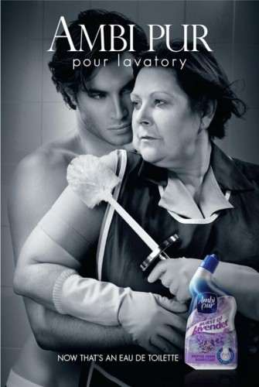
The print advertisement for ‘Ambi Purs’ new Lavender bleach is both comical and a parody of established perfume advertisements. There are a number of conventions used in this advert that can be seen in other ads but that is the point of it. It is supposed to have the look of a perfume ad but have enough of its own techniques that it is it’s own advert and not a direct copy of another brand.

The colour scheme used in the advert is greyscale. The grey colour adds a dramatic feel to it, which mirrors the position and expressions seen on the models faces. The colour scale can be seen in perfume ads like ‘BVLGARI – Jasmin Noir’ and ‘Giorgio Armani – Acqua Di Gio’. The ‘Ambi Pur’ ad then does the same as most perfume ads by including a small picture of the actual product that is then in colour, so it catches your eye and you are aware that the product being sold is the perfume/ bleach.

In contrast with perfume ads however, this advert defies the usual models used. Where most adverts use a male and female who are both attractive, fit, tanned, semi-naked and appear confident and desirable. Whereas the ‘Ambi Pur’ advert uses a female model who is the complete opposite. This model is much older than the usual models, not as fit and she is portrayed as a common woman. By having her in a cleaner’s outfit she is seen as working class, which is a fair representation of modern society. However, it could be seen that the advert is actually generalising working class people and saying that women are cleaners and the males are successful, which then borders sexism. All three of the ‘Ambi Pur’ ads portray the same woman with the same male while she is cleaning up and the two are seen in sexually implied and/or dynamic positions which enforces the idea that sex sells products.

Aldi Advert

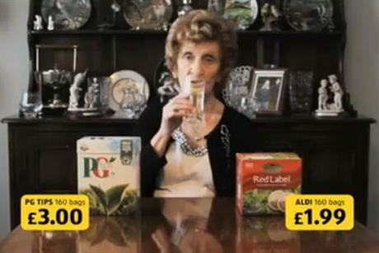

This ‘Aldi’ advert is a comical take on comparison advertisements. All comparison advertisements play on the fact that their store is the best-priced store for a particular product. ‘Tesco’ uses baskets to symbolise how much you can buy from their store in comparison to competing stores, where as this ‘Aldi’ is more simplistic and does not try to push their store on audience. The advert simply has two products, a well known branded product and a less known brand sold in the ‘Aldi’ store. The price then comes up in yellow, a bright enough colours to catch audience’s attention.

The overall message of the advert is ‘Why pay more for the same product?’ The older lady featured in the ad has a neutral and almost un-bothered look on her face, mirroring the idea that people shouldn’t be bothered about brand and that price is more important. However, using the older lady in the advert could be seen as stereotyping older people to be drinking tea a lot, although the overall message about spending more on the same thing is more prominent than supposed stereotyping.

http://www.bitterwallet.com/commerical-break-ambi-pur-own-perfume-ads/71419

