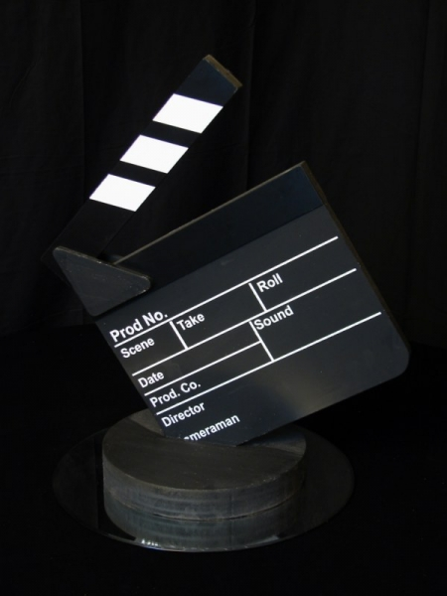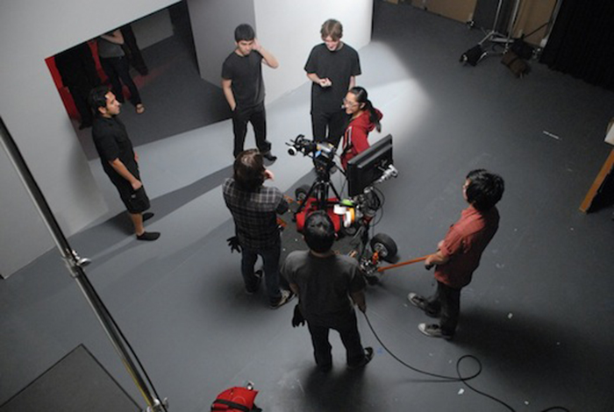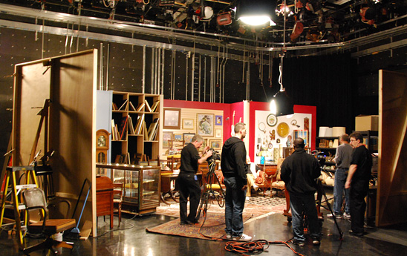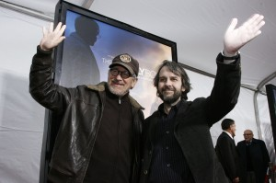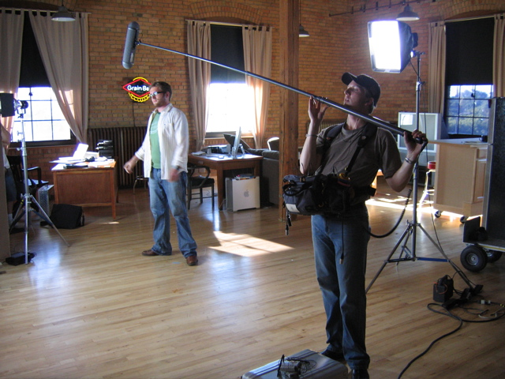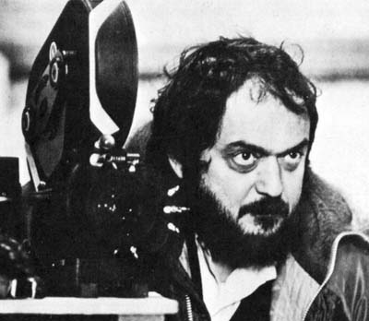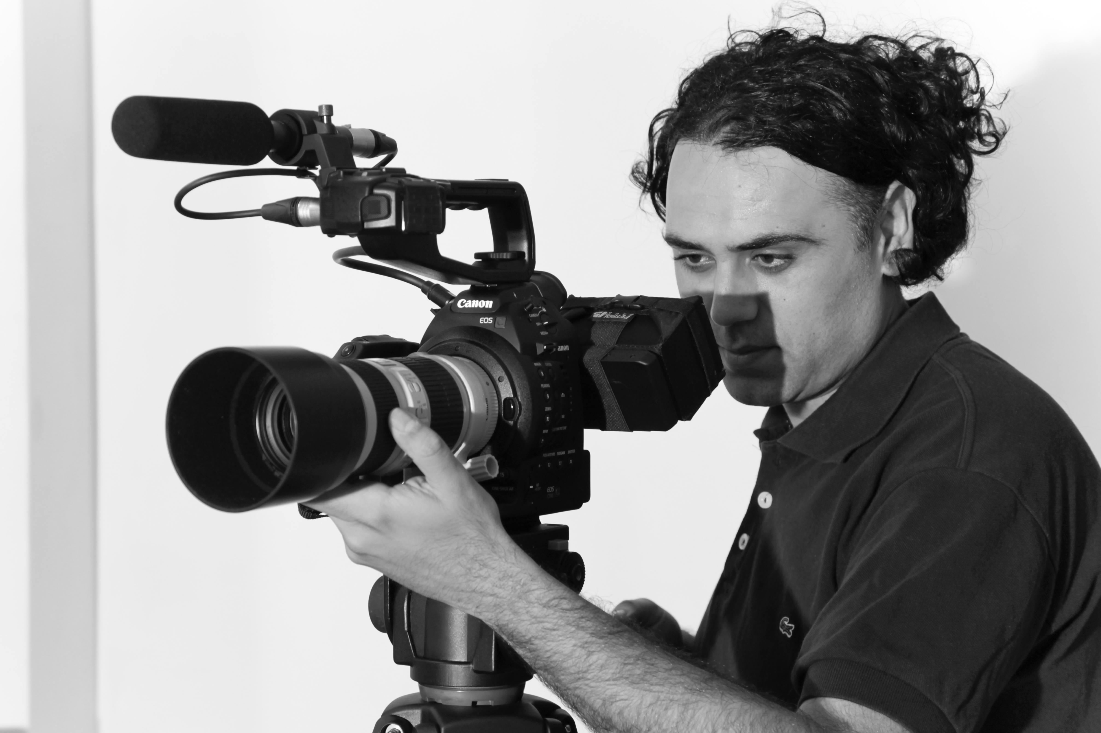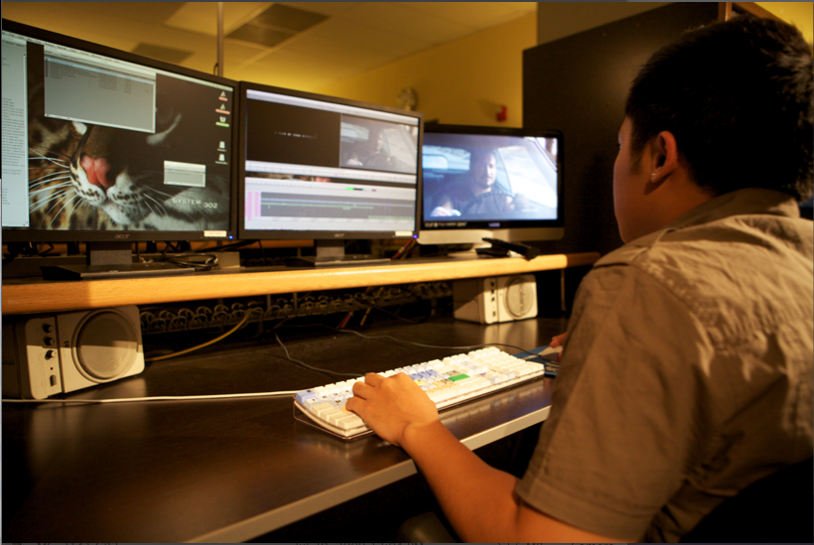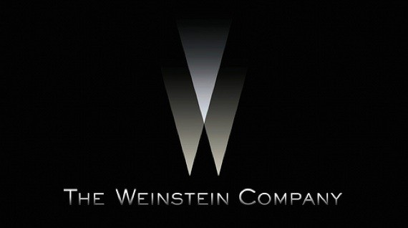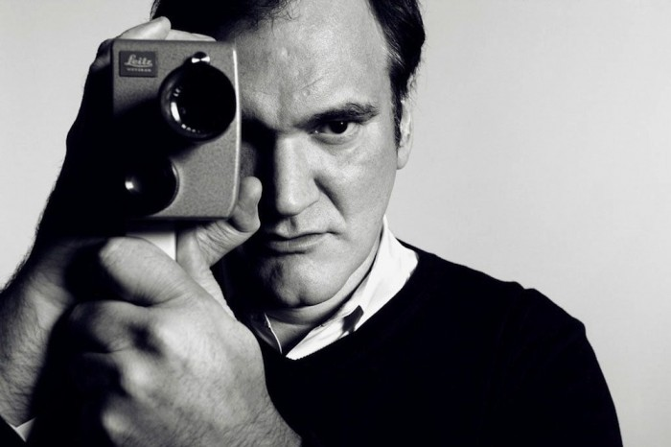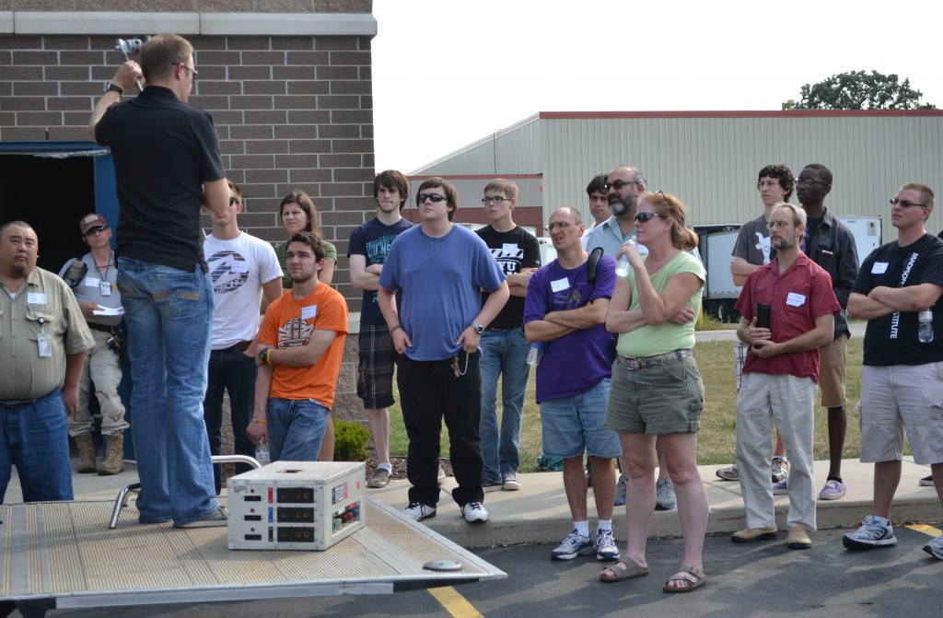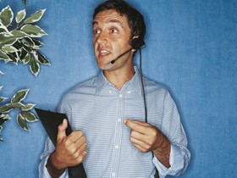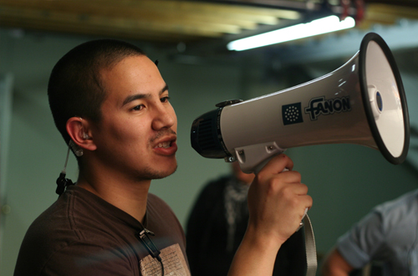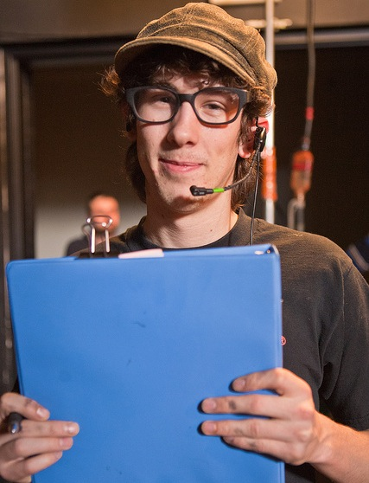

Within the film industry

Callum Harrison

Job Roles

**Set Decorator**

A set decorator is in charge of arranging and sorting out all the materials and hiring the necessary builders, props and miscellaneous items ready for the shoot. The decorator works closely with the production designer to help establish a visual look for the film. They also both choose and decide on the large props needed and when. A decorator will analyze the script to create a list of needed materials before starting the hiring and purchasing process before the shoot.

**Storyboard Artist**

A storyboard artist is tasked with drawing and sketching a visual representation of the script. Each scene and shot is broken down to cuts and each cut drawn, either in a basic form or a detailed and extensive form. This job requires not only brilliant drawers but also a person with patience, creativity and a deep understanding of the script itself. They would collaborate with the director so that they both know what each other wants for the shot and to capture a vision for the film.

**Screenwriter**

The screenwriter quite literally the person who writes the screenplay which is then purchased and converted into a feature length film, short film or television episode. They can either be commissioned to write a script based on their notoriety in the industry or submit one as an amateur writer wanting to break into the industry.

**Executive Producers**

There are several types of producers in the industry. An Executive producer is the person or persons that both supervise and help prepare the filmmaking process. They are vitally important to the process because they are the ones who pitch a film idea to big studios in order to gain funding. Once a film has been green-lit the executive producer could begin to focus on the business and budgetary side of the production and legal contracts however they still oversee the entire process.

# Pre-Production Job Roles

**Director of Photography/ Cinematographer**

A DoP is the person who is in charge of both the camera and lighting teams on a film or television set. The DoP works closely with the director so that they can get an idea of the director’s vision for the scene so that they can then direct the lighting crew. Depending on the director, the DoP might have room to make some decisions themselves on how some scenes should look. Some directors might be strict and have the DoP do everything that the director envisions.

**Sound Recorder**

A sound recorder is the person who is responsible for recording all sound on location or on set, monitoring the quality of sound during production. They work closely with the director and boom operators so that they can record quality sound. Most of the recorders work takes place in production but they can work closely with a sound mixer in post-production.

**Assistant Directors**

1st, 2nd and 3rd Assistant Directors (usually abbreviated as AD) are in charge of organizing the schedules and overseeing a lot of the running of the production. Working with the director and other assistant directors, they sort out the necessary shooting schedules; call sheets and logistical elements for the days, weeks and months to follow. The AD's are also responsible in calling the attention of everyone on set to begin filming and calling out such things as 'Final Check', 'Lock It Down' or 'Set' at different point during the pre-shooting portion of the scene.

**Director**

The director is the most influential creative person in the filmmaking process. The role of the director is to ensure the flow of the plot by directing actors, camera movements and lighting to ensure a creative and astatically pleasing, well told and acted story. Despite the control over the process and the influence the director has they are still under the producer in terms of control because it is the producer who liaise between the studio and director to ensure that the film is to the standard of the studio.

# Production Job Roles

**Editing Assistant**

The editor’s assistant is in charge of keeping the running of the post-production process. They shuttle between the post-production offices, labs and sound departments gathering or collecting the pieces needed to put into the film. They must also maintain the editing software during the process so that it continues to work throughout. They also have to note and check for technical glitches or problems with the shots given to them by production runners.

**Film Distributor**

The distributor can either be a company or individual who is in charge of marketing the film. They are the people who decide a release date and which format they will distribute on; theatrical release, on demand, straight-to-DVD or simultaneous release. This job involves a lot of making sure that things are ready and moving along as planned and when needed. Film prints need to be shipped, ticket gross needs to be set and marketing materials such as posters are ready when they are needed.

**Film Promotion**

This job involves a large group of people working together to promote the film. Creating the advertisements, trailers and print posters are all undertaken by the promotion department before the film is released. Roughly a 3rd of the films budgets are used for the promotion of the film, however depending on the film, whether it be studio funded or independent, the promotional campaign could be much smaller and cheaper if the budget isn’t sufficient enough to promote it.

**Editor**

Often considered an invisible art, the editor is in charge of cutting the film itself together. Working close with the director, they both work together to create a look and pace while cutting and piecing together the final film. The role is an intense and pressured job because it is their job to ensure the pacing, continuity and rhythm of the film is kept consistent throughout. The editor may create several versions of the film; rough cut, producers cut, extended cuts and director cuts.

# Post Production/ Distribution Job Roles

**Production Manager**

Working closely with the line managers, a PM is responsible for managing the films budgets and department budget planning. Their main role is to assure the film shoot is running on budget and schedule.

**1st , 2nd and 3rd Assistant Director**

1st, 2nd and 3rd Assistant Directors (usually abbreviated as AD) are in charge of organizing the schedules and overseeing a lot of the running of the production. Working with the director and other assistant directors, they sort out the necessary shooting schedules; call sheets and logistical elements for the days, weeks and months to follow.

**Director**

The director is the most influential creative person in the filmmaking process. The role of the director is to ensure the flow of the plot by directing actors, camera movements and lighting to ensure a creative and astatically pleasing, well told and acted story.

**Production Assistant**

The production assistant can be separated into different categories for different departments. Some films might have more assistants than others depending on the budget.

**Production Runner**

A production runner comes on board just before principle photography begins. Their job is to keep communication between the crew departments through paperwork like call sheets, notes and maybe scripts.

### The following is a basic ladder to climb for an aspiring director