Hush - 2009

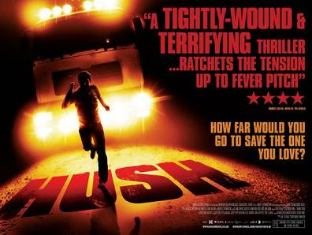

Hush is a 2009 horror film directed by a former BBC1 Radio DJ Mark Tonderai. The film was funded by Film4 the UK Film Council and Warp X on a budget of £1 million. The film took £90,455 in the UK and $288,667 worldwide. So it did not make a profit. It was distributed by Studio Canal (Optimum, which specialises in distributing independent films. It did not release a soundtrack but there were several TV interviews featuring both the lead actor William Ash and the director to help promote the film.

