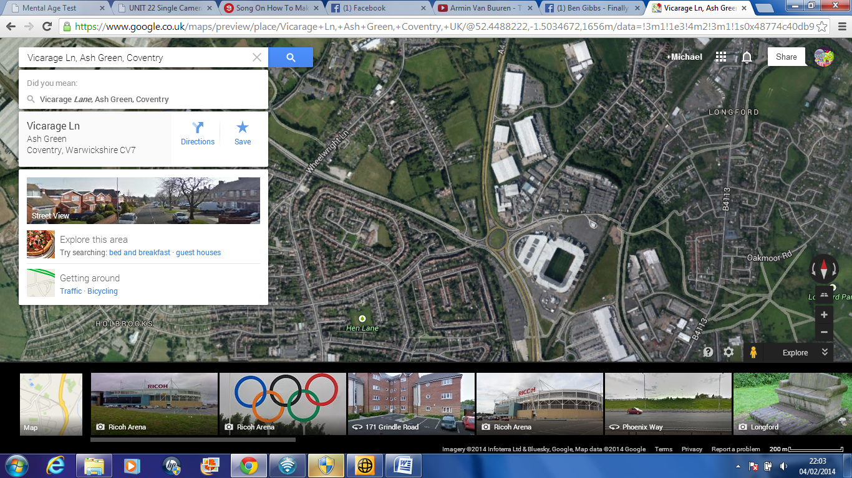

Here is a somewhat close up of the nearest entrance/Exit points to the A444.These are the closest entrance/Exit points to the desired location and are not that far away from the actual location.

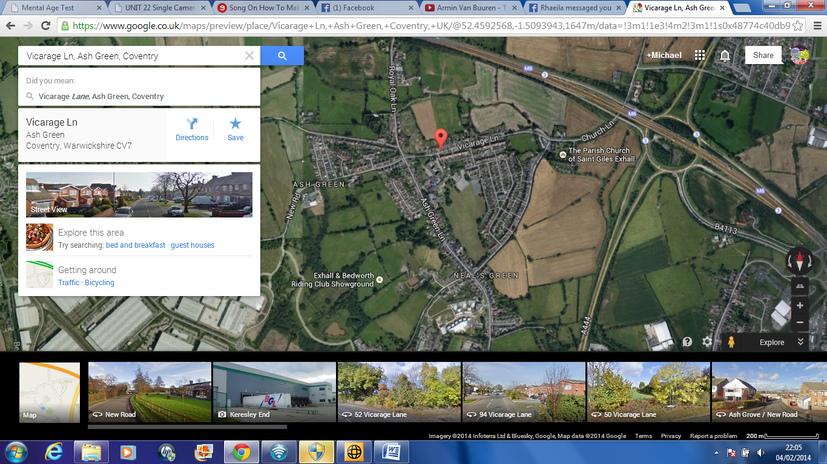

This is a close up of the actual location where we hope the filming process can happen.

The venue is situated on Vicarage Lane in Ash Green.

The location isn’t far from the entrance to the A444(see above)

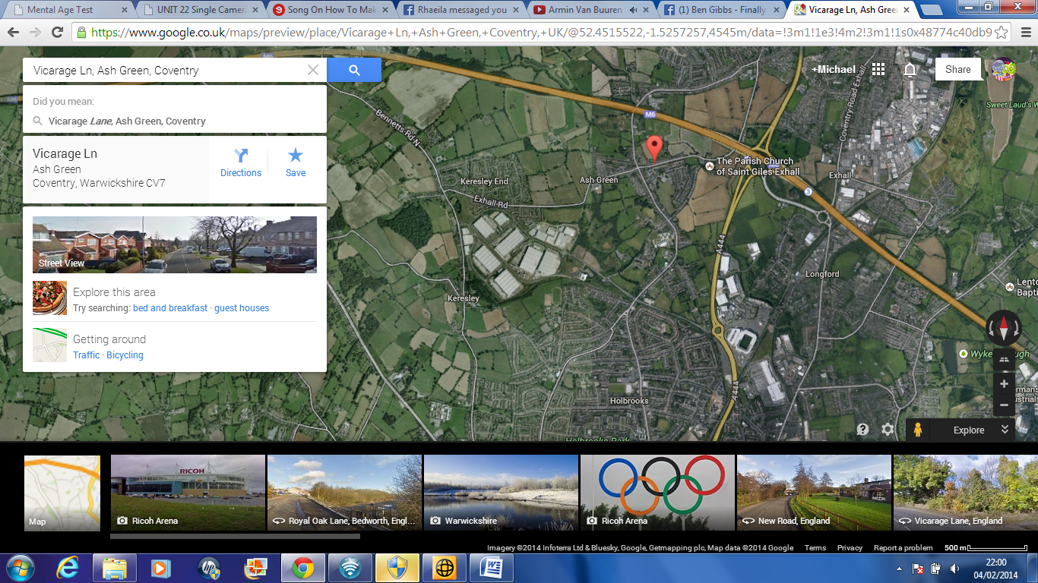

This picture here is showing the correlation of the Filming location and the nearest motor way/bypass entrance and exits

This is the pin point of the desired location for filming.

As you can see the location isn’t far from the entrance/exit to the A444 bypass.

This is the entrance/Exit to the A444 bypass. These are the nearest entrance/exit points to location and are not that far away.