Montage Editing

A montage is ‘the technique of selecting, editing, and piecing together separate sections of film to form a continuous whole’. The montage has been used in many mediums, such as photography, music and film. The movie poster for ‘The Truman Show’ is an example of a photomontage.
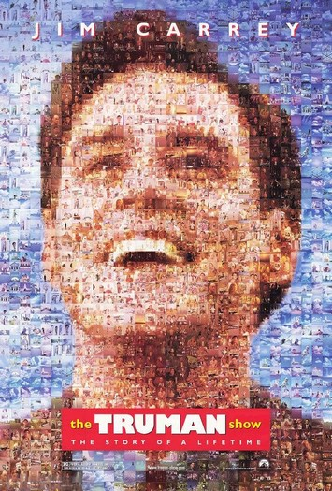
In filmmaking a montage is a contrast to continuity editing. A montage consists of a series of scenes cut together to make a disjointed sequence, showing events usually happening at the same time across a different time or place. An example of this is in ‘Star Wars Episode 3: Revenge of the Sith’ where Palpatine has initiated Order 66. Then there follows a sequence in which the audience is show a vast number of familiar Jedi’s being murdered on different planets. This is an example of events being condensed down into a short sequence.
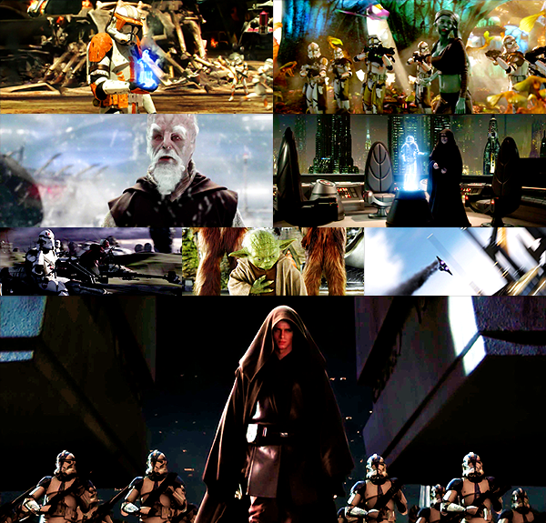
However, there is another approach to montage called the Soviet Montage. A Soviet Montage is concerned with showing a symbolic meaning to what is being shown, rather than showing a passage through time like a normal montage. Russian film director Sergei Eisenstien was the theorist whose theory about a montage being a series of shots being on top of each other, rather than next to one and other like a normal montage.
His 1925 silent movie ‘Battleship Potemkin’ featured the ground breaking and influential scene entitled ‘The Odessa Steps’. The scene is cited as the original montage sequence as it showed soldiers arriving on the steps, a mother a child running then the child being shot, a group of people hiding behind a structure and many people running and dying as the soldier’s massacre them. The scene showed the onslaught from different perspectives consisting almost of short stories of people caught up in the shootings. Only through montage could he have shown the different characters at the same time as the overall massacre was achieved because continuity editing would have meant the scene being considerably longer and making little sense as the scenes would start and finish at random points throughout the entire scene. This is an example of soviet montage as the shots shown all happen at the same time rather than at different times and places that are condensed into one scene.
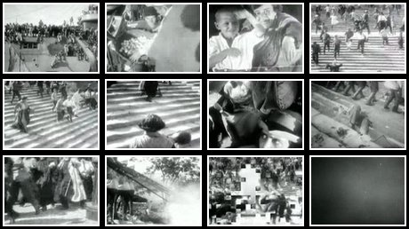

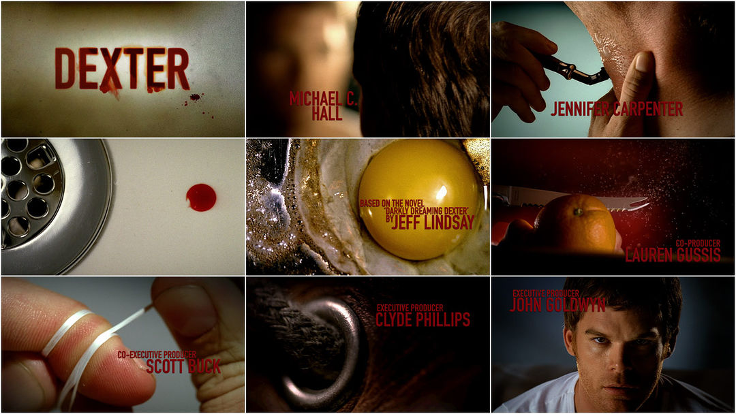
Montages have also been adopted in television. In television, montages are used in most, if not all series. The opening credits of almost all show are examples of montages. For example, the ‘Dexter’ opening credit sequence is a montage. The minute long sequence ties together a number of shots from Dexter’s morning routine.

http://oxforddictionaries.com/definition/english/montage
http://wtanaka.com/system/files/truman_show_ver1.jpg
http://1.bp.blogspot.com/-oxec0k32N-w/TsMxh949m8I/AAAAAAAAAgE/0zGq8G180qw/s1600/order+66.png
https://biogrph.wordpress.com/article/sergei-eisenstein-1x4qvbqoz9orn-184/
http://cdn4.artofthetitle.com/assets/resized/sm/upload/hd/vg/uz/du/dexter_contact-0-1080-0-0.jpg?k=ce2d6767a8

