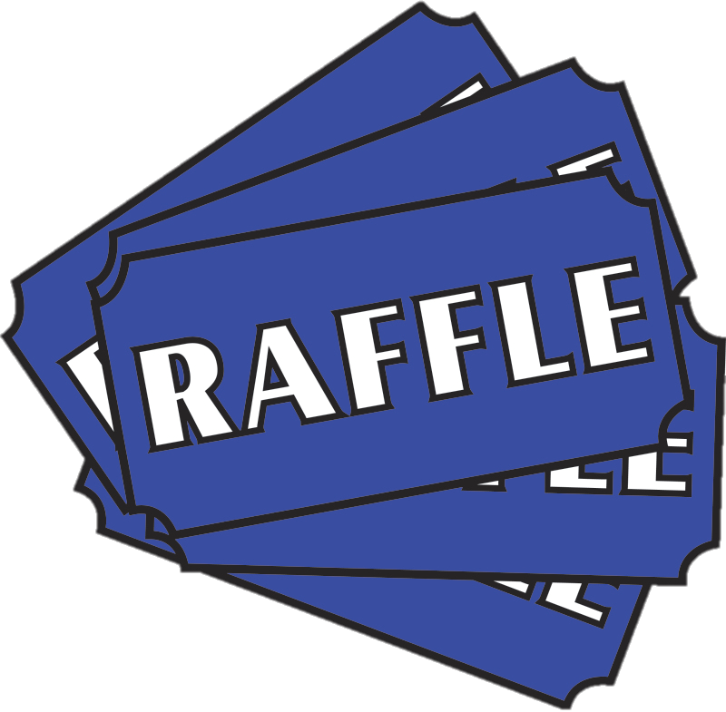

**Food and Drink**

**Penalty Shoot Out**

**Bouncy Castle**

**June 22nd 10am – 2pm**

**Longford Park Primary School**