Roles and responsibilities:

When making a film there is a beginning and an end. At the start of the film making process, a producer has the idea to make a film. There are lots of key parts in the making of a film and over 500 different roles depending on the size of the film. When you want to make a film you are going to need to crew as without the crew then you are not going to be able to make the film because you wont have the crew to do the different tasks required. A crew is important because you can’t do everything on your own. The first thing that the producer will ever need is a writer, as he needs an idea for the film. Without any idea or stimulus then there will be no film. The producer will try and find a writer who has written something similar to what he had in mind, to do this he will either ask the director if he knows any writers or he will find one himself who he knows is good and trustworthy. When the producer has found a writer he will talk with the writer and discuss his ideas and plans.

Now the producer and writer have discussed ideas they start to go about writing a script for the film. In the script writing part of the film the writer will usually come up with the story of the film and everything that happens in it, for example what the characters look like and where the story is set.

Next the producer needs to find a director whom he will use in making the film, the director will often give his views on the film idea the director has the ability to visualize how a script will be acted out and the perseverance to see a long term project through. The director works with the screenwriters and producer to determine the way to visually present the ideas being developed. An experienced director would know which cinematographers and set designers would be best suited for the given project, or he might just choose the people who he/she feels comfortable with.

The very next part is for the director, as he needs to find actors and crew. The director is given a budget to work with and with that budget he has to go and find the actors and crew that would be necessary for making the film.
The director will find all of the roles such as drivers, cinematographers etc…
The director cannot keep the money as it is used to pay for the crew and all equipment needed, the director doesn’t actually find the crew himself/herself he/she would get a line producer to find the crew. The director sometimes suggests the actors but any actor can be used, and the actors are usually contacted through their agents.

The next part is finding the right location for the film. The line producer would hire a location scout who would go out and visit specific locations related to what is needed for the film. When the location scout arrives at a location he would use his camera to take pictures of it so he can show the director when he gets back to the studio. The location scout visits lots of locations taking pictures of each one. When the location scout gets back to the studio with all of the photographs needed the director will look through them and choose the ones he feels are best for the film. After the choosing process has finished the next thing to do is to send the basic crew out there. The basic crew sent out would be the director, Gaffer, DOP, Location manager.
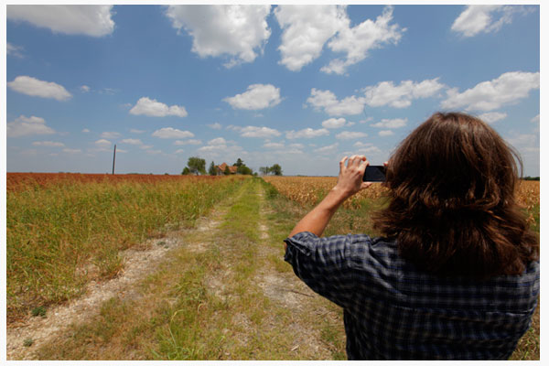

The location manager will probably get there first so he can find out where the parking is and where the toilets are. The location manager has probably studied the location months prior to everyone arriving on location. The reason the production manager has researched the location so intensely is so that he knows about what facilities are nearby like restaurants or hotels. The location manager is in charge of the location.
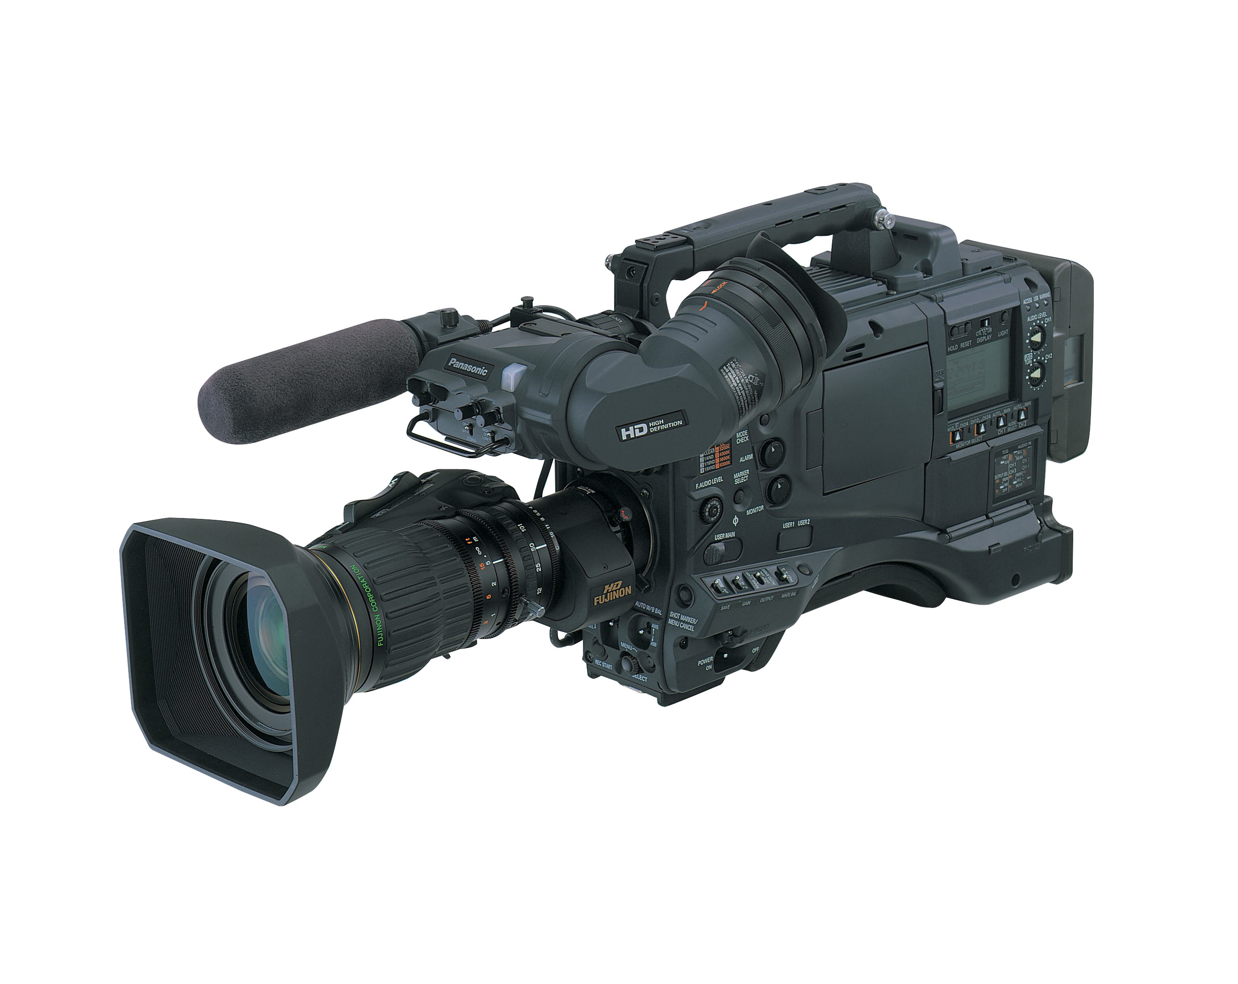
After that the director, and DOP will arrive. The Gaffer is there to analysis the area to work out what lights are needed. The director will already have a storyboard made by a storyboard artist. The DOP is there to work out the different shots, looking out for where the sunlight is or what physical features there are in the location they will be filming. The Gaffer is the head electrician so he is in charge of all of the equipment needed up until they start filming as they will have the best boy to take over and make sure all of the equipment required is there. The DOP suggests what lenses to use for the cameras and what shots will be best for a scene. The director is different to the DOP (director of photography) because the director is more swayed to the acting side of the film however, the director can overrule the DOP or anyone because he is in charge. So for example if the DOP suggests a 50mm lens and the director wants a 18mm lens then the DOP will have to use a 18mm lens because it is what the director wants.
The next part is planning how the scenes will look, the mise-en-scene. This is the main job of the DOP however, the director can still overrule what the DOP has suggested because the director interprets the emotional aspect of the shot for example if the shot is a sad scene then the director will ask the DOP to make the scene look darker and gloomier, and take out colours to make the scene feel sad.

The next part of the film process is making the set. Now to make the set you are going to need people like foremen, Riggers, Welders, Plasterers, Scenic carpenters.
The first part of making the set is the set design. The crew would have a few set designers who would design the set to how to Director wants. The set designers are in charge of how coming up with ideas on how the set is designed.
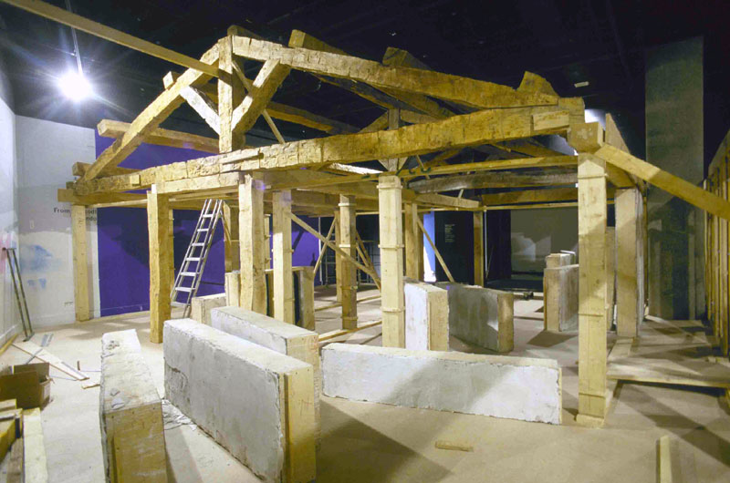
After the set has been designed you will need carpenters, Riggers, Scenic Carpenters to come in and actually build the set. First you would have the construction supervisors come in and interpret the blueprints and allocate labor and resources.

The carpenters would come in and start work on the set following the blueprints given. Every now and then the photographer takes photos of the set, showing the progression of the set being built to the director. Then the electricians will come in and wire the place so that it can be lit

When the set has finished being wired and constructed the painters would then come in to decorate the set to how the director wants it.

When the set is finished a green room is built so that when the actors have finished a scene, they have somewhere to go so they are not on set.

After this you will start actually making the film. You would bring in the makeup and costume designers. The makeup crew would put stuff on the actors so they will look like the character they are supposed to be portraying, and then the costume designers will make the costumes for the characters according to the script and what the director wants. The costumes and makeup play a very important role for the film because they make the characters look how like the characters they are portraying.

The next part is where the camera, sound and lighting crew come in along with the actors so that the filming process can begin.

Important people in the camera department (Includes Lighting) are people such as the Grip, Director of Photography (DOP), Camera operator and Gaffer,

Important People in the sound department are people such as the sound system operator, ADR Mixer, Boom operator and sound recordist.

Once everyone is there filming is started. The actors get into positions and they start filming each scene as the film progresses. The scenes are filmed in order and may take several attempts to perfect as the scenes need to be perfect.
After the filming has finished, the film enters the postproduction stage. This is where editors take to work on the raw film footage and add effects and other things to make the film a finished product. When this process has finished the film is ready to be published and shown in cinemas all over the world

