Adverts are an everyday thing in this day and age; we see them all over the place from the TV to the Internet and the Radio, even billboards
The aim of an advert is to simply advertise. This could be for a product or a service anything they want people to pay to use.
They make up so much of the media today and they all have one common goal. To make you buy a product or buy into something.
Adverts come in many forms, whether they be animated, a mixture of special effects and real footage or all real footage, like I said they all have a common goal and that is to successfully sell their product to the masses.
You may have noticed that some “adverts” are not adverts, but instead are known as promotions or just promos in short. Promotions are little videos which intend to get you to want to see that live event or to go and see something. WWE Inc. is a massive wrestling company owned by Vince McMahon. They are notoriously know for their really good promos as they have monthly Pay per view events which viewers watching at home have to pay to watch. Like the regular shows people have to pay to attend these shows live. They have a new Pay per view coming up in the next few weeks called Payback, the promo for this event shows Professional wrestler and COO Triple H (Paul Levesque) loosen his tie and flip a table in anger whilst saying “I always try to do what’s best for business, but when they bite the hand that feeds them… you have to put them back in their place. Because what goes around comes around! And what’s best for business… is payback!”
WWE Payback Promo: https://www.youtube.com/watch?v=uj6NjiS-Tjs
Below is the poster used by WWE to help promote the event…
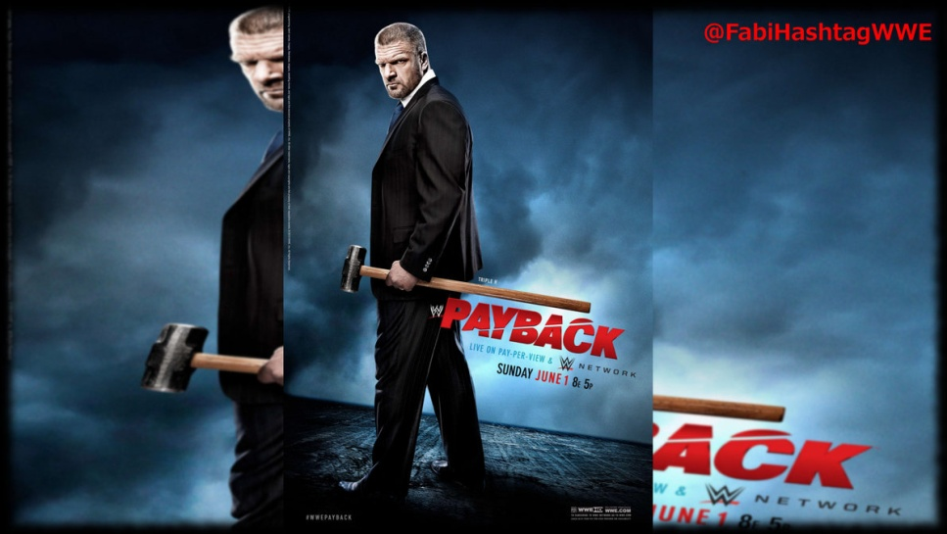
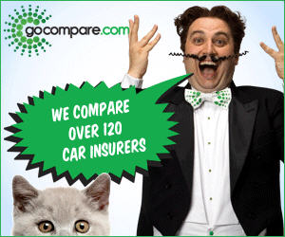
Some adverts may come in the format of a series, using the same characters each time but changing a bit. A very well know advert which uses this technique would be the “Go Compare” adverts which see the annoying Oprah singing man go around singing a song about the company constantly sing the companies name “Go Compare” in the song. The adverts song is designed to come across as very catchy and also very annoying, making it successfully stick in people heads and thus making them remember it.

Sexism is used in many different adverts, aiming the product to a certain gender. Take for instance the snickers advert. The snickers advert showed a footballer rolling around on the floor pretending to be hurt, when all of a sudden a big tank charges through with none other than iconic tough guy Mr T from the A-Team driving it, Mr T says “Quit your jibba-jabba you ain’t hurt! If I catch you acting like a crazy fool again you’re gonna meet my friend pain!” “snickers, get some nuts!” The advert is clearly advertised at men because is gives the idea that you’re not a man or at least not manly before you’ve had a snickers bar. This makes the bar of chocolate appeal to men making them want to buy the bar in hope of becoming manlier.
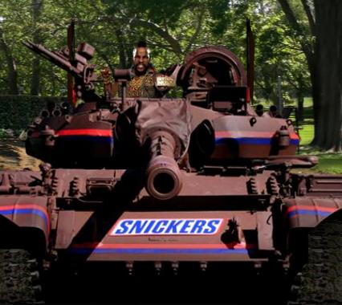
Below is a still from the first advert.

Compare and Contrast
The Lexus IS Poise advert uses a ballerina to compare and contrast the car to. The amazing body control found in ballerinas is used in this advert to imply that the car has amazing body control with great grip and very little body roll and stability at all times
Hidden and Overt messages: Hidden and Overt messages are an found in all adverts, some adverts only have overt messages and some only have hidden messages. If an advert has an overt message It means the message of the advert is put straight out there and is clearly obvious, on the contrary if the advert has a hidden message, then you will have to look a bit deeper in order to find out what the adverts message is.
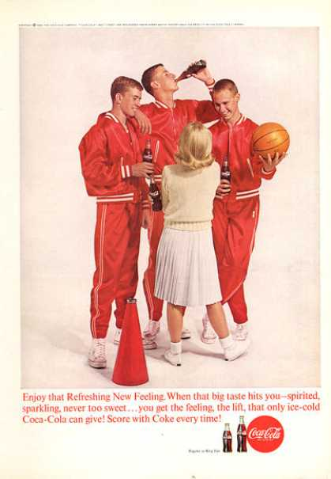
A hidden message is something that grabs people’s attention, A subliminal message. Often with products like Coca-Cola and Pespi you find that the subliminal messages are something along the lines of sex or something of a sexual nature. The way they portray the sex theme is very subtly, you have to look slightly closer to see what they did.
Take this Coca-Cola ad, you can see what the message in this advert is, it shows the feel good factor you supposedly get from drinking Coca-Cola. It also suggests that drinking Coca-Cola attracts women and makes you look cool, making it appeals to the target audience. The advert implies that women love Coca-Cola and therefore being seen drinking Coca-Cola will make you stand out to women.
In terms of overt messages you will often find that they are shown in words rather than anything else, take this Twinings tea advert. The text at the bottom says “Twinings gets you back to you” and along with the rest of the advert you can clearly see that it is about finding yourself again. The advert shows a woman climbing and wandering through a landscape until she eventually finds herself and becomes one, holding a cup of tea (twinings tea). The adverts suggests that the drink is for those people who just need to chill out after a long day at work, for those people who just need to go back to who they are normally without the stress and worries affecting them, hence why the text says “gets you back to you”.

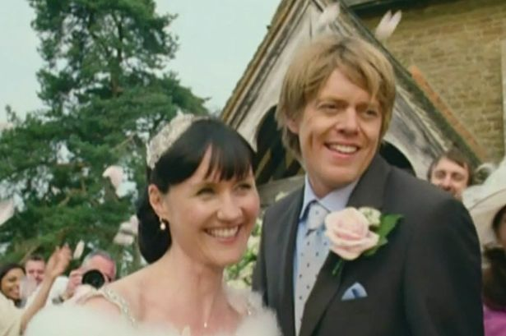
Some adverts come in series almost with an advert that has a progressing storyline that goes on each new advert comes on. A brilliant example of an advert series would be BT’s Adam and Jane adverts. The adverts followed two lovers (Adam & Jane) as they go through awkward moments ect… The adverts really engage the viewers as they often ask the public to vote on what happens next. People were eager to watch every new advert episode BT released.

When making and releasing an advert you need to make sure it goes through the ASA (Advertising Standards Authority). This is to make sure that your advert meets all of the rules and to make sure that it isn’t offensive, misleading or harmful.
You also have to go through Ofcom and make sure you have the appropriate broadcasting licenses for TV. You need a license to broadcast your advert or else you are commiting something illegal and you could be prosecuted and sued, so make sure you use ofcom and legally gain the right to broadcast your ad.
BARB or Broadcasters’ Audience Research Board is an industry standard television measurement service for broadcasters and the advertising industry. These companies own BARB: BBC, ITV, Channel 4, Channel 5, BSkyB and IPA (Institute of practitioners in advertising)
When making an advert you have to find a channel you wish to broadcast your advert on, it could be ITV, BBC, Sky the list goes on. When you have chosen the channel you wish to broadcast on you must agree terms with them such as what time you want your advertisement broadcasted or in-between what program etc. depending on the time and what program you decide to have your ad broadcasted next to the cost may dramatically increase or decrease. The channel you wish to broadcast on comes up with the price you will have to pay.
Lets say you want your advert broadcasted in between a program like coronation street, due to the sheer amount of viewers who watch coronation street you will most likely have to pay a lot of money maybe up to £300,000 or more! If you have your advert broadcasted at a time like midnight then the cost will be almost nothing as not so many people watch the TV at midnight.
Basically the more viewers that will see your advert, the more it will cost you.
You need to make sure your advert is suitable for the target audience it is aimed at, for example and kids advert for a toy should in no way have a sexual theme neither should it have any foul language ect… you need to make sure it is acceptable for the audience you intend to advertise to.
A brilliant technique in selling a product is using endorsement from someone well known, famous or iconic. If someone sees your advert and they see one of their idols or someone they look up to then will be more persuaded to buy the product, it’s a crafty technique that can really work and get you those customers.

