TV ADVERT IDEAS

ADVERT ON MOBILE PHONE
ADVERT FOR
MIXVIBES
DJ
EQUIPMENT
ADVERT ON A KIDS TOY

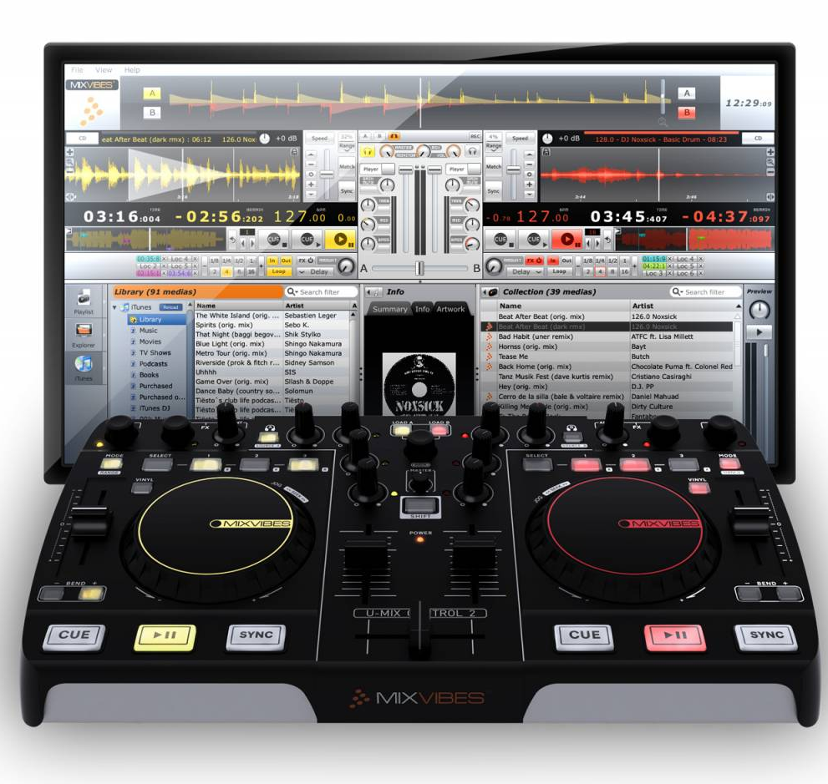
When coming to the task of making an advert, I had three possible choices, which I each liked the idea of. The one that stood out to me the most was of course the advert for Mixvibes’ DJ equipment. I have a great passion for DJing so making an advert for a DJ mixer and showing off what it can do seemed a very good Idea.
We are now making an advert for the Mixvibes U-mix Control 2.

OUR CLIENT: Our client for the advert, or just simply the person we are making an advert for is Mixvibes. They are just about to release some new DJ equipment and one of their newest releases is the U-mix Control 2 Midi DJ controller.
They have told us that they have a high competition with other brands of musical equipment such as Pioneer and Behringer. They need us to really show of the true capabilities of the mixer in hope that it does well in rivalry to the other company’s efforts.

The Product: The product is aimed at those aspiring DJ’s that are on a budget and need some style. We have tried the mixer many times now and we will be using the mixer in the advert to show off what it can do…
Having used the mixer I can honestly say that there is barely any problems with it. The build is very sturdy and strong and wont break easily. The layout is very simple and is effective when playing gigs live, as you wont be unsure of where things are like effects.
The one downside of the mixer is that it doesn’t have a built-in sound card, however sound cards are sold by Mixvibes and also they are realeasing a pro version of this mixer which does have a built-in sound card.

The price of the product is very good, at £115 your money is not going to be wasted at all. There are Midi DJ controllers that have way less effects and capabilities that sell for higher prices than the Control 2 Midi Mixer.

What our client wants us to do: Our client Mixvibes wants us to successfully portray the Midi Mixer in way that catches peoples eye in a way that makes them think “wow I must buy this!”
They want to outsell other competitors, making them the better DJ equipment manufacturer.

The budget for the whole is project is around £50,000 so we have enough money to produce an excellent quality advert.

Legal and ethical issues:
While there are no ethical issues present in the making of this advert, there are legal issues that have been cleared up. Making the advert has led to copyright issues due to the songs and videos used in the advert. However we have contacted the rightful owners of the songs and videos and have legally gained the right to use the clips and songs.

In some adverts there have been ethical issues that have really put a lid on their attempts, however we can safely say that there are no ethical problems with the advert we are producing.

The DJ using the DJ equipment in the advert is of legal age to be in the advert without needing a parent or guardian. The DJ didn’t want to have his face shown in the ad so we made sure that we stuck to our promise.

